**Implementation and Visualization of Graph Algorithms using NetworkX and Tkinter**

**A PROJECT REPORT**

**Submitted by**

**Sadeem Sattar 19K-1102**

**Sanjay Kumar 19K-1052**

**To**

**Sir M. Waqas Sheikh**

CS302 - Design and Analysis of Algorithm



**FAST NUCES**

**15 DEC 2021**

Table of Contents

Abstract 2

Introduction 2

Proposed System 2

Experimental Setup 2

Results 2

Conclusion 2

# Abstract

The visualization of algorithms is intended to facilitate the understanding of algorithms through graphical UI to verify execution of algorithms on the selected input data file.

The aim of this project is to analyze and compute graph algorithms. Graphs have been generated and displayed according to the algorithm selected. The main category of algorithm which are included in graph algorithms are clustering coefficient, shorted-path, minimum spanning. The nodes included in input data files are ranging 10 to 100. The project is done on NetworkX and Tkinter libraries.

# Introduction

Visualization of various graph algorithms is shown in this project. Those algorithms are listed below:

* Prims
* Kruskal
* Dijkstra
* Bellman Ford
* Floyd Warshall
* Boruvka
* Clustering Coefficient (Local & Global)

Input data files are located in Benchmark folder from which the file is selected and then specified algorithm will be performed on that file after that graph is visualized.

# Proposed System

The proposed system is implemented using NetworkX, Tkinter and Matplotlib. Entire view of system is provided below which shows that from GUI window user can select file and it is read by the program after that user can select algorithm to apply then there will be computation based on that algorithm after that there will display of computed graph using matplotlib.

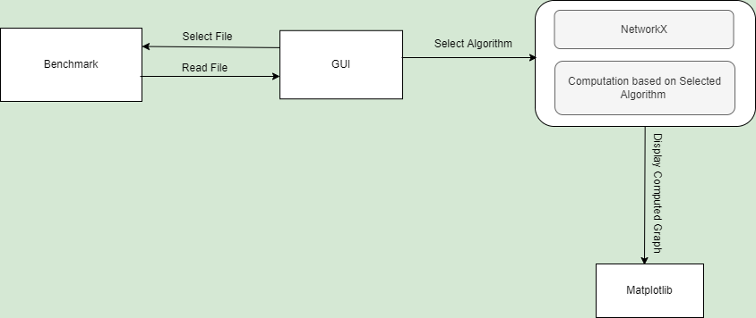

# Experimental Setup

* Visual Studio Code as Code Editor
* Python Installation for using it as programming language.
* Installation of NetworkX Library for creation, manipulation and study of the structure of complex networks.
* Installation of matplotlib library for low level graph plotting.
* Installation of Tkinter library for Graphical User Interface.

# Results

Results obtained after computation on graph algorithm from benchmark folder are listed below:

|  |  |
| --- | --- |
| 10 NODES | |
| ALGORITHMS | RESULTS |
| Prims | 25.35 |
| Kruskal | 25.35 |
| Dijkstra | 56.69 |
| Bellman Ford |  |
| Floyd Warshall |  |
| Boruvka | 25 |
| Average Clustering Coefficient | 0.6583333333333 |

|  |  |
| --- | --- |
| 30 NODES | |
| ALGORITHMS | RESULTS |
| Prims | 103.65 |
| Kruskal | 103.65 |
| Dijkstra | 183.15 |
| Bellman Ford |  |
| Floyd Warshall |  |
| Boruvka | 103 |
| Average Clustering Coefficient | 0.698094 |

|  |  |
| --- | --- |
| 50 NODES | |
| ALGORITHMS | RESULTS |
| Prims | 144.3 |
| Kruskal | 144.3 |
| Dijkstra | 298.49 |
| Bellman Ford |  |
| Floyd Warshall |  |
| Boruvka | 144 |
| Average Clustering Coefficient | 0.6114 |

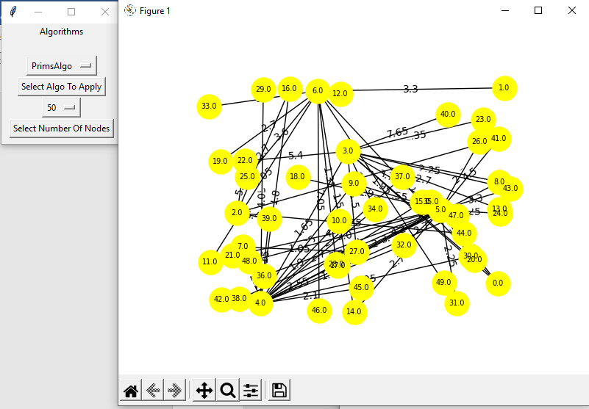

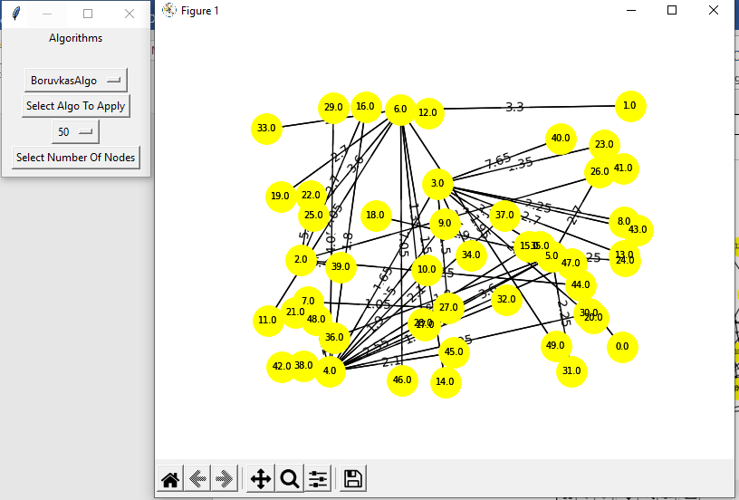

# 

# Conclusion

The analysis and visualization of graphs with various algorithms had shown the cost required and time to compute that graph algorithm with different size of nodes and edges.